**MOBILE APPLICATIONS DEVELOPMENT PROJECT**

**GLOBETROTTER**

(Online Hotel Booking Application)

**Group Name: FRIENDS**

**GROUP MEMBERS:**

Harjot Singh Dhami (c0739350)

Harpreet Kaur (c0734830)

Kawalpreet Kaur (c0740009)

Lakhwinder Singh (c0738047)

**PROJECT IDEA:** We are working toward the development of a mobile application from which the user can book hotel rooms online.

User will register with username(e-mail), password, age and phone number.

This application will allow the user to login through his/her e-mail and password.

User can update his/her profile. He/she can update age, phone number and password.

Once he/she logged in, user can view and search the Hotel list according to location

User can also add any hotel to his/her favourite list by simply clicking on it.

user can view the various items (Hotels) in a list with small description (Image, location, details) and an image.

After that the user can choose to book a room by selecting the check-in and check-out dates and finally entering the card details.

**WIREFRAME:**

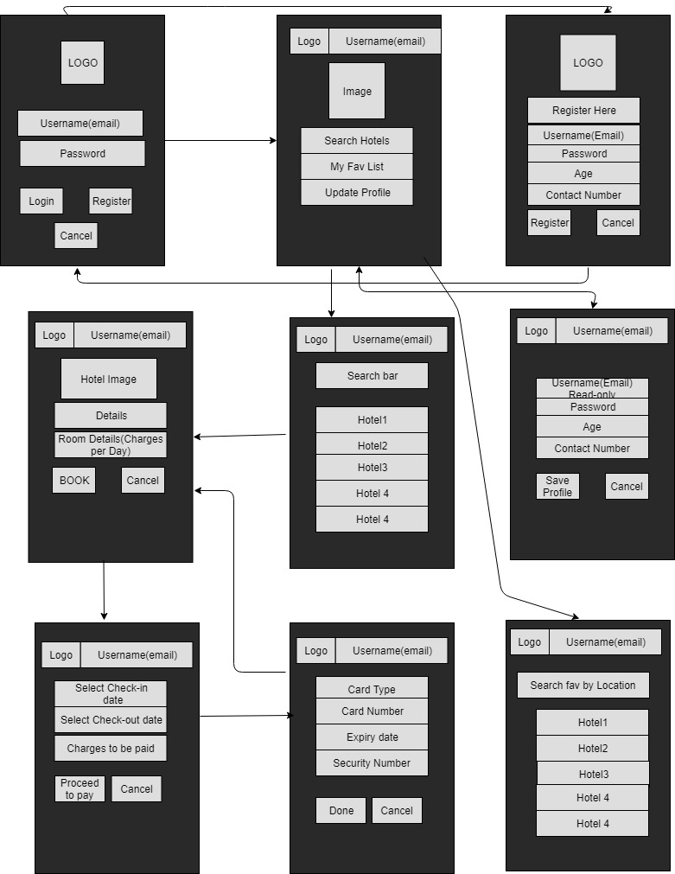Following is the Wireframe for the project: